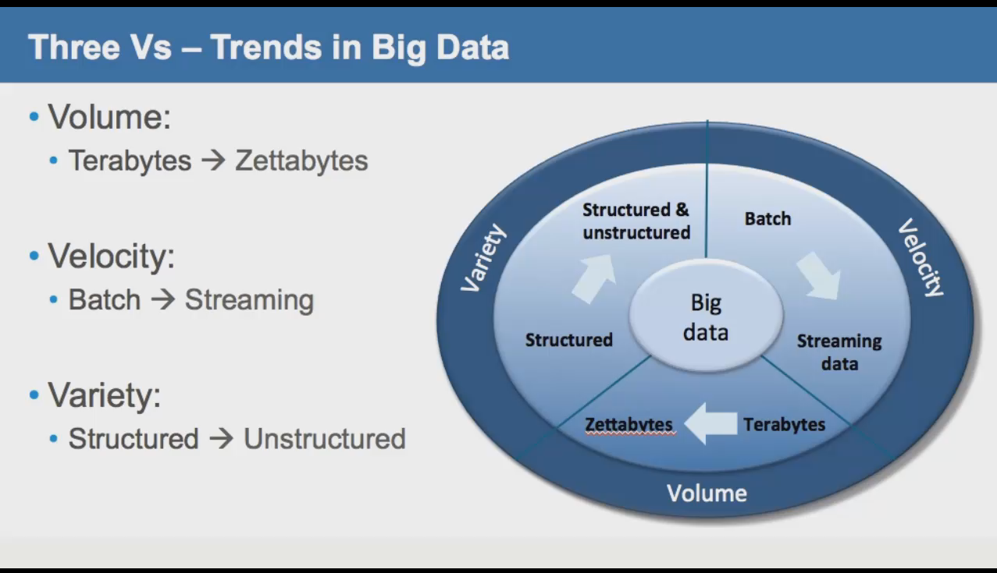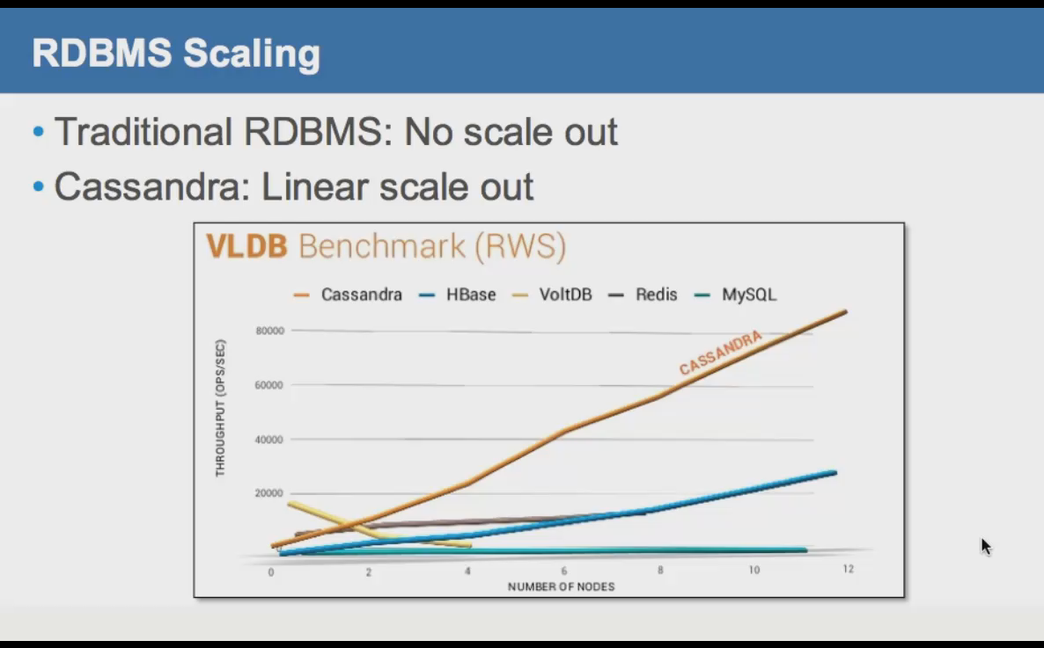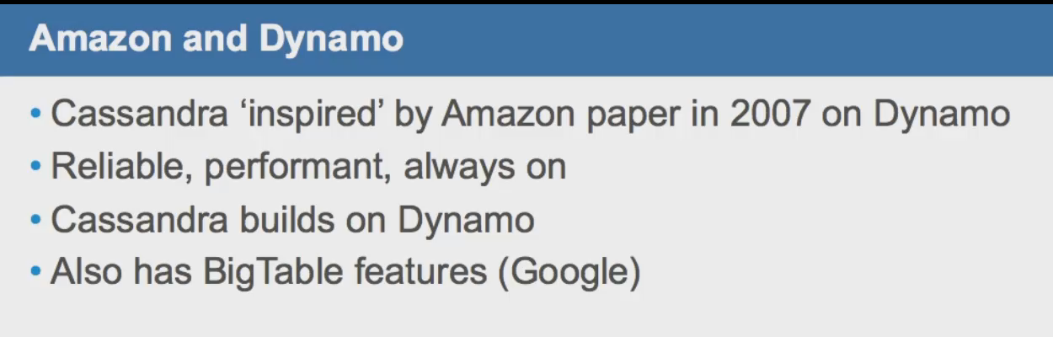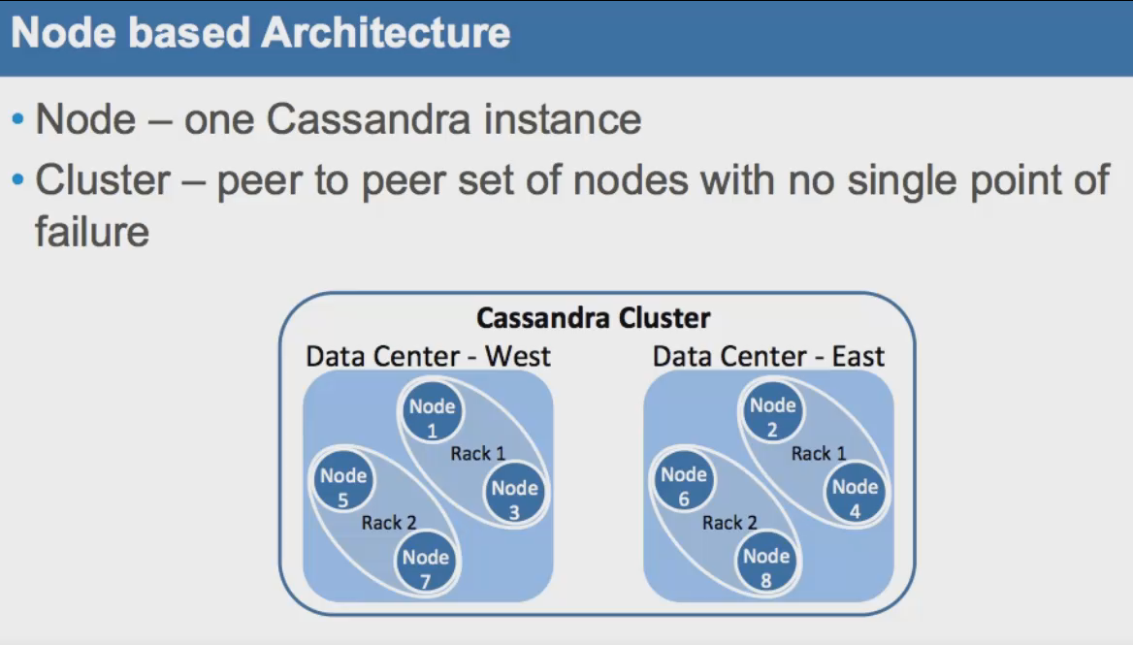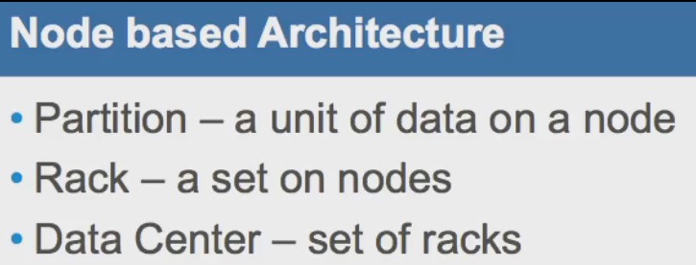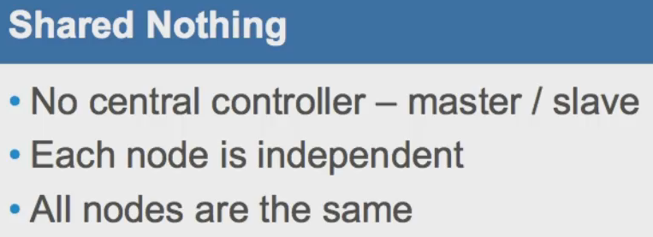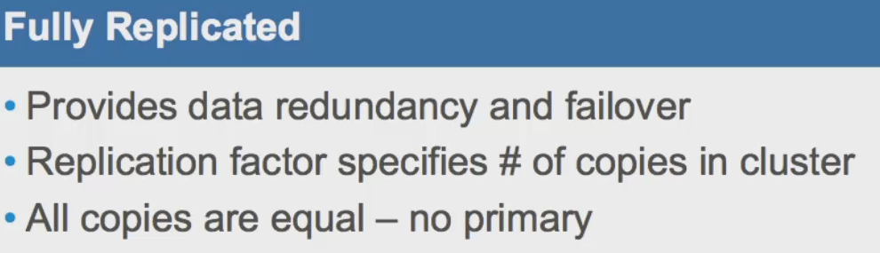

# IN CAP, you can choose only two, Cassandra chooses AP.

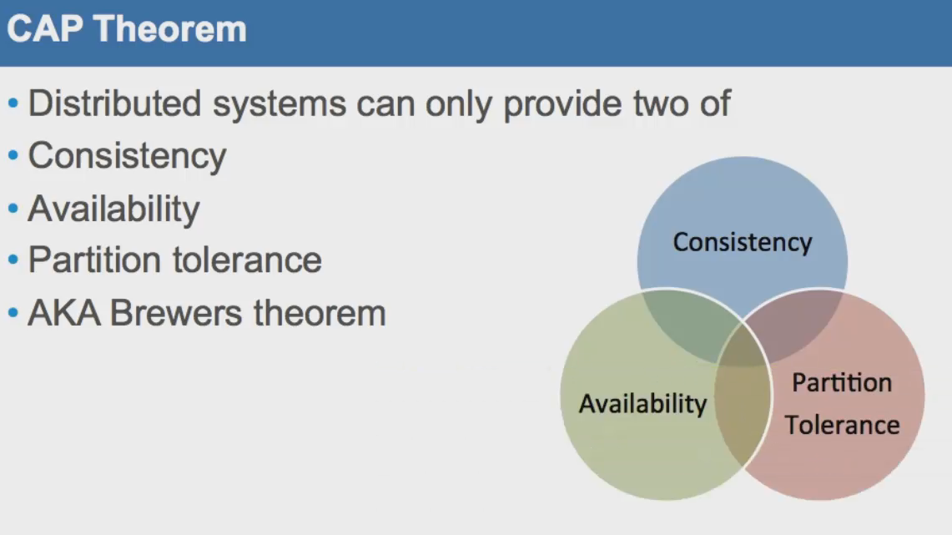

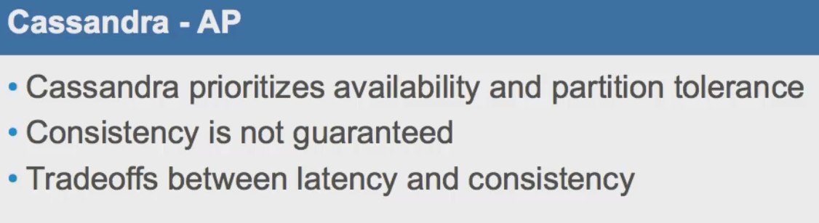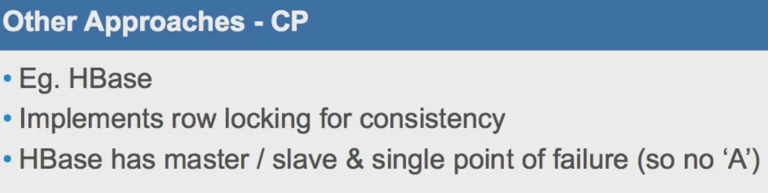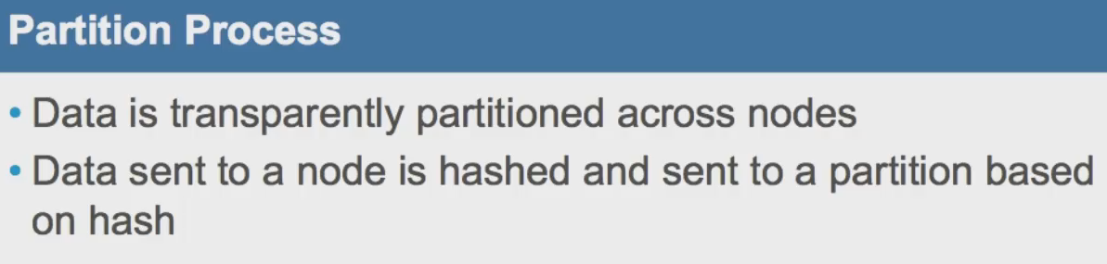

# Random Partitioning is preferred. Using it we can use cluster best for reads and writes. Ordering Partition Ways – Pipe Order Partition, Order Preserving Partition. Ordering partitioning is not preferred.

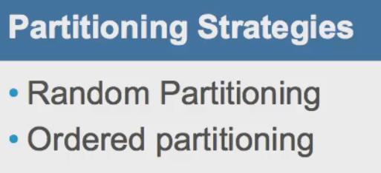

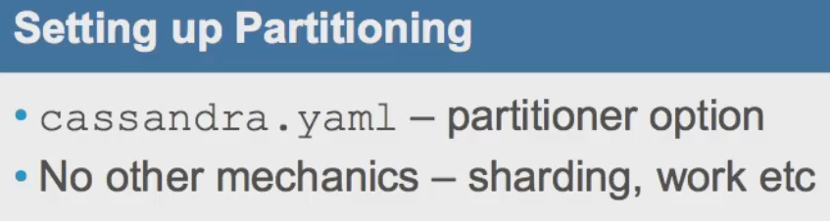

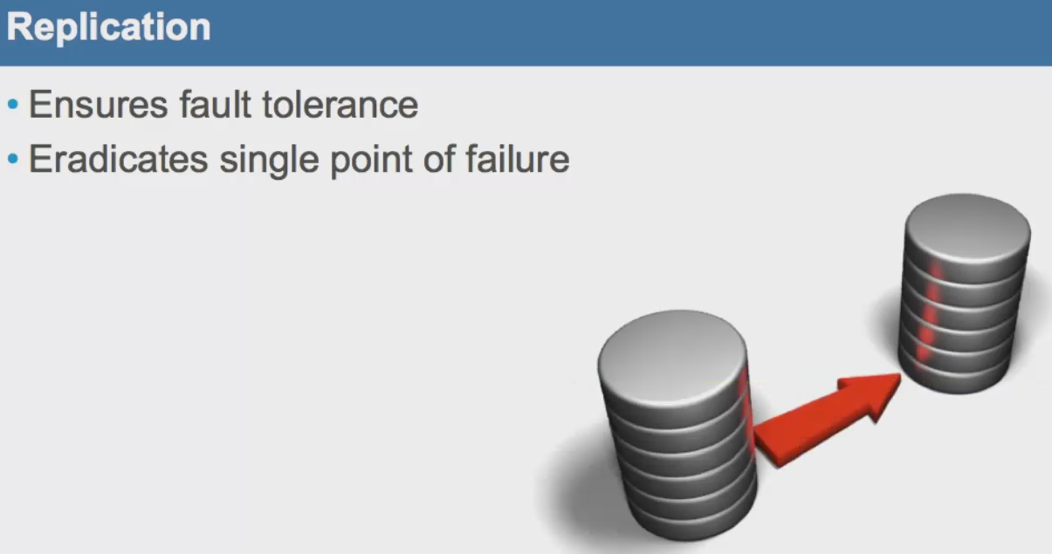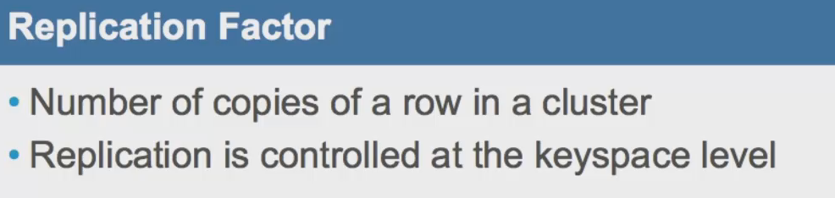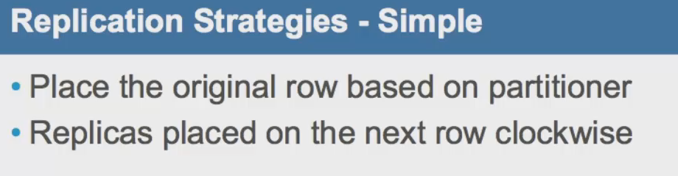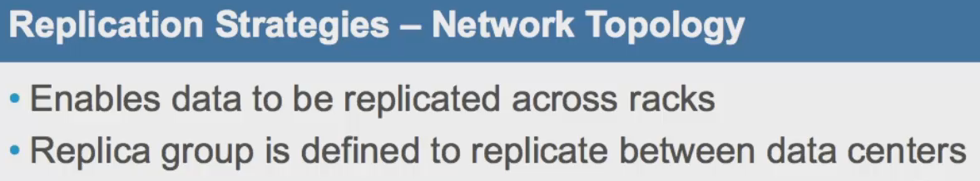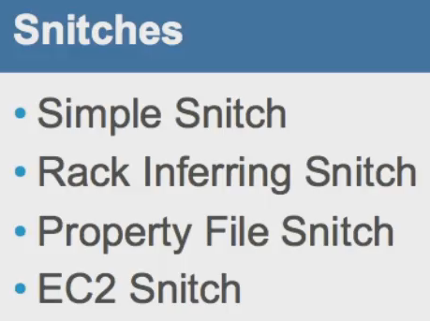

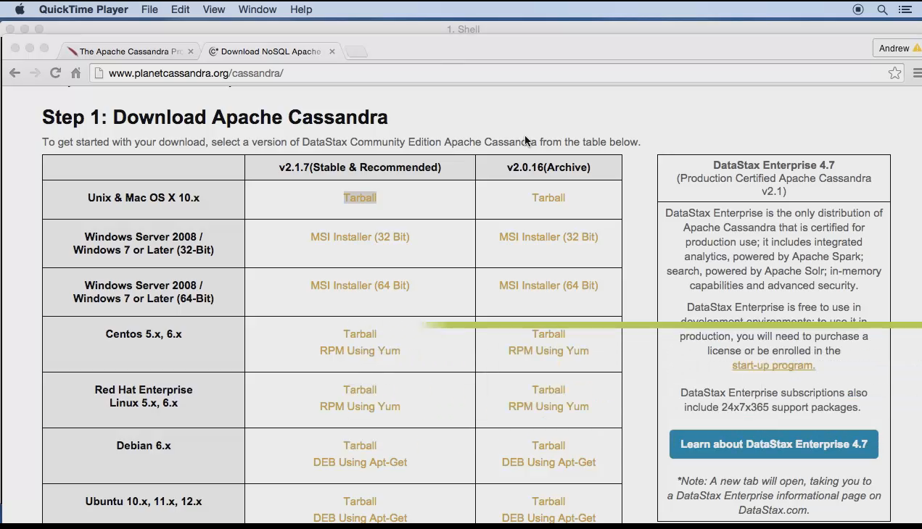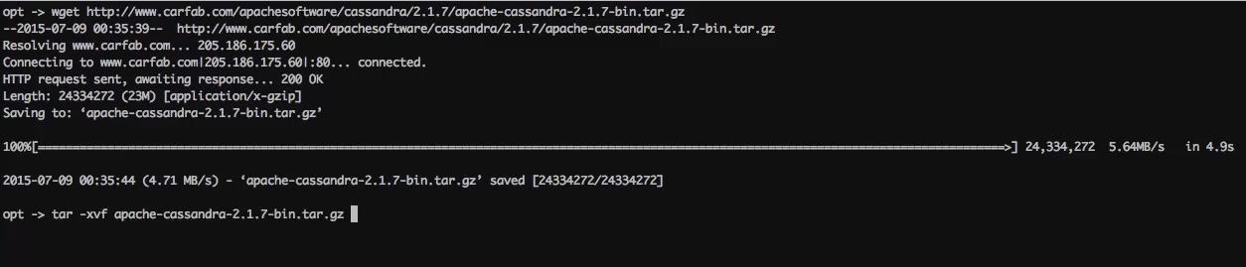



In conf folder, In Cassandra.yaml, you can set paths for below:

* Data directory
* Commit Log directory
* Saved Caches directory

All these directories should be on separate disk.

# Starting a NODE in Cassandra:-



-f means process will run in foreground. After node starts, you will see data/ dir. It will have commitlog, data and saved_caches directories.

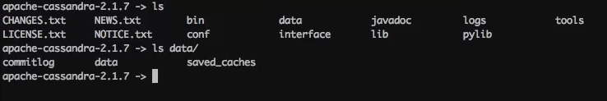

# Starting and stopping Cassandra Instance:-

To start ,

Bin/Cassandra –f

To stop just use Ctrl+C. If –f not used to start open new terminal. And

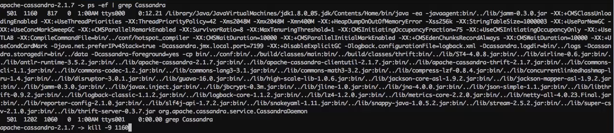

# NodeTool:-

In bin/nodetool

Using Help : bin/nodetool help statusthrift

Running thrift server:

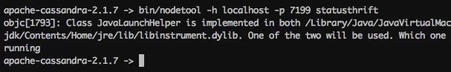

# CQL Shell:-

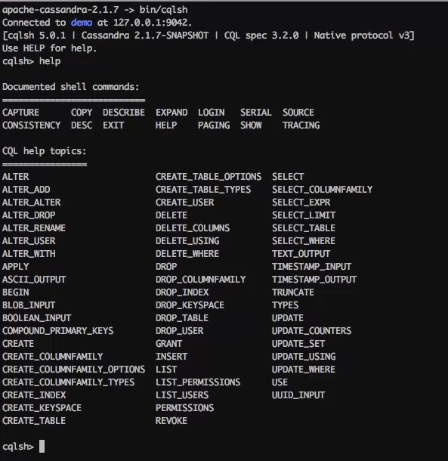

Creating KeySpace and columnfamily:

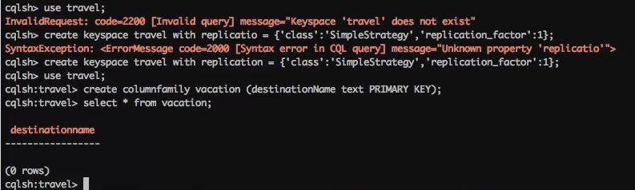

# CASSANDRA CLUSTER MANAGER (CCM):

# Installing CCM:

Installing Dependancies:

* Brew install libyaml
* Sudo easy_install pyYaml
* Sudo easy_install six
* Brew install ant
* Wget <https://bootstrap.pypa.io/get-pip.py>
* Python get-pip.py
* Pip install psutil
* Pip install ccm

Check CCM installation:

* Ccm list 🡪 shows demo cluster
* Ls ~/.ccm/ 🡪 Lists files

CCM only works on localhost for now.

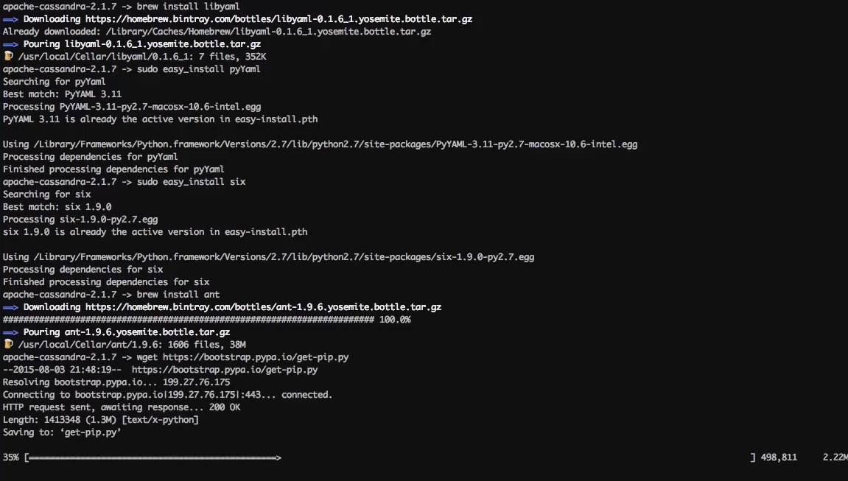 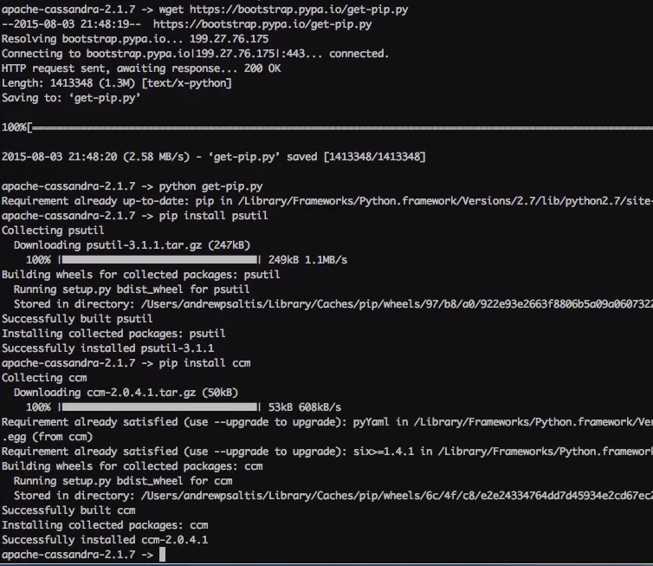

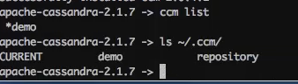

# Creating Cluster with CCM:

* Ccm create {cluster_name} –v {Cassandra_version _name}

Ccm create DEMO –v 2.1.7

* Ccm populate –n 3 🡪 This will create 3 nodes in the cluster DEMO

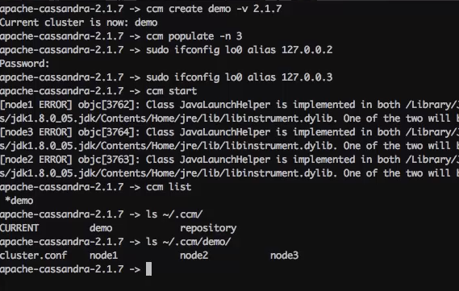

This JAVA error is nothing. You will get it for all nodes.

# Using CCM commands:

Ccm help

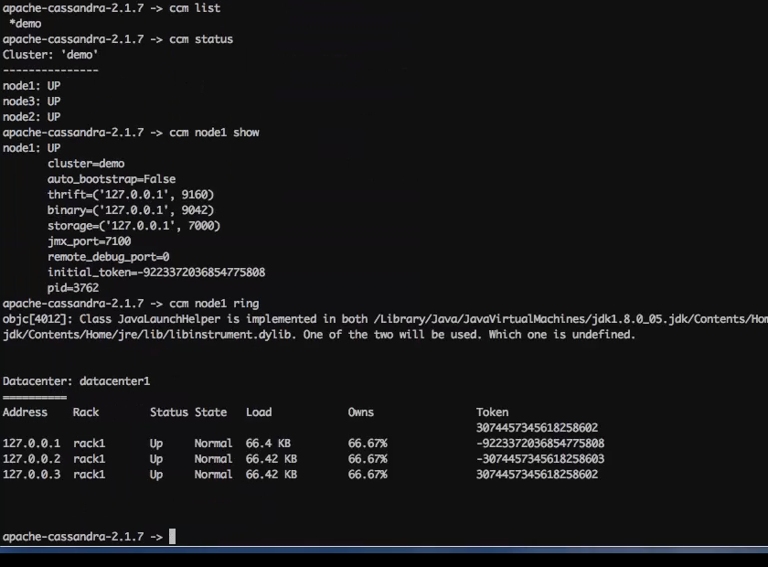

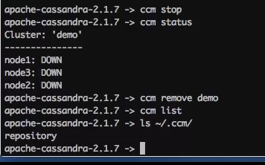 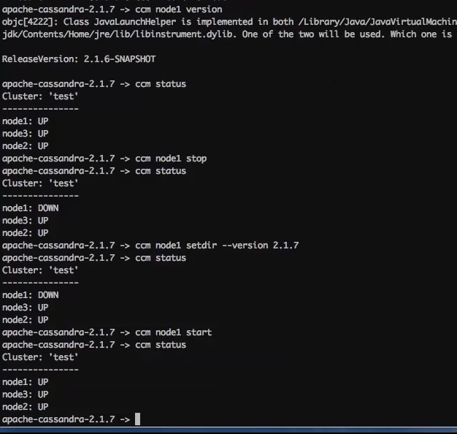

# Troubleshoot CCM:

Ccm node1 showlog

# DEVELOPING with JAVA

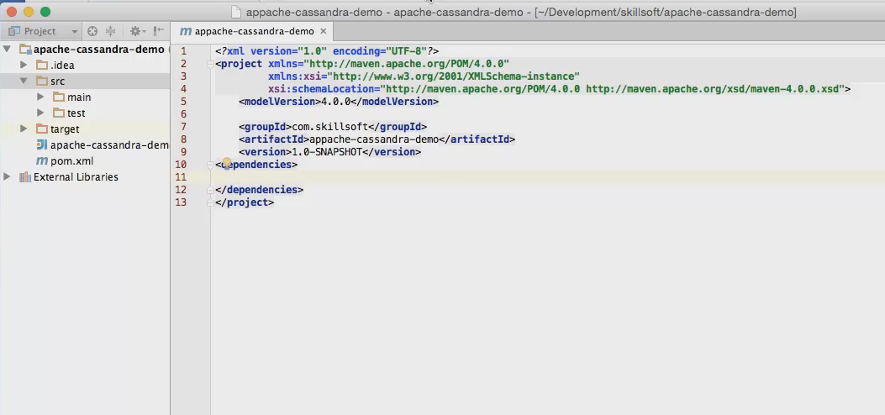

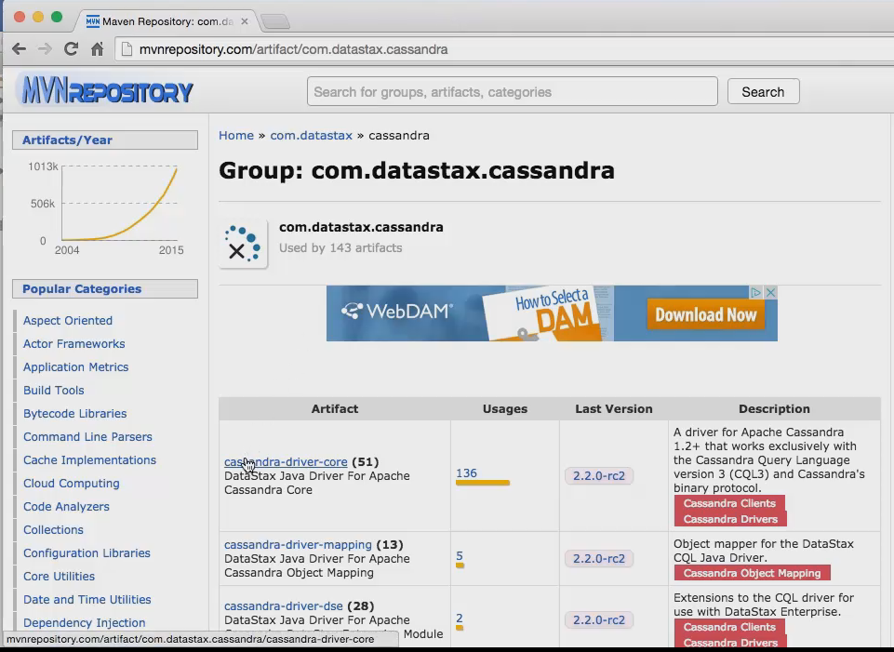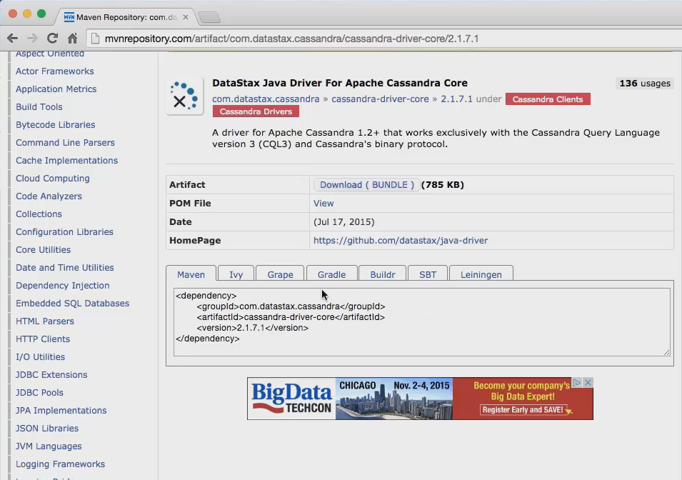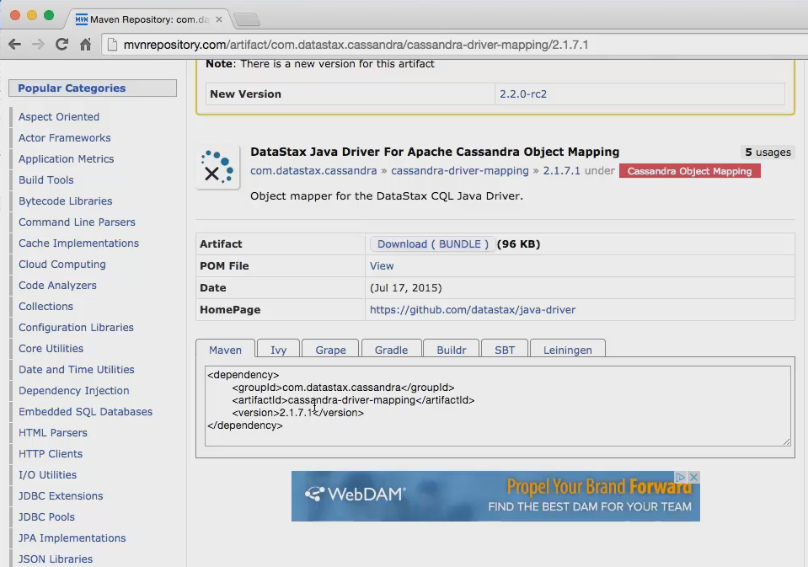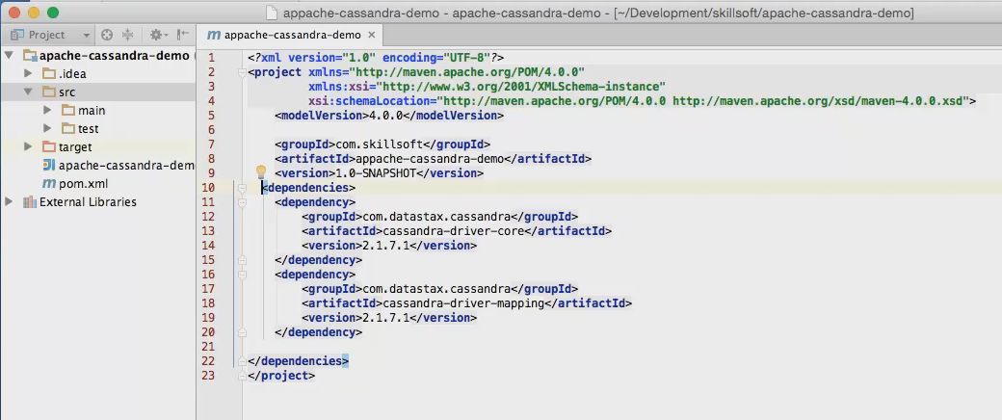

# Program : Connecting to Cluster

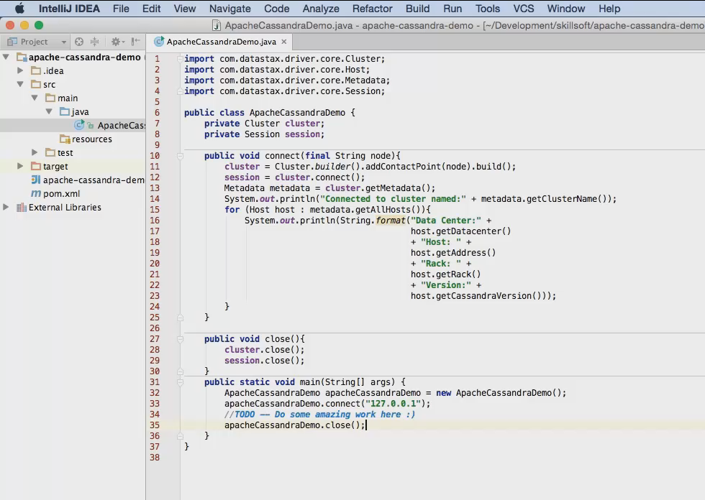

# Querying from JAVA

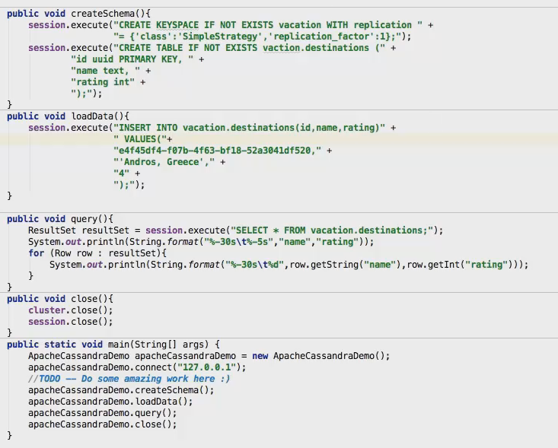

Update Data: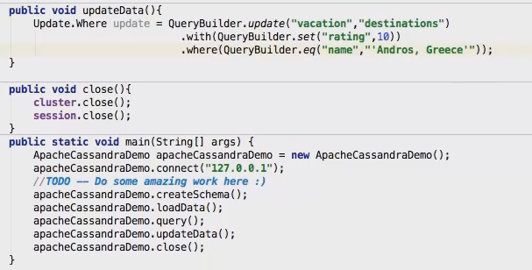

Delete Data: 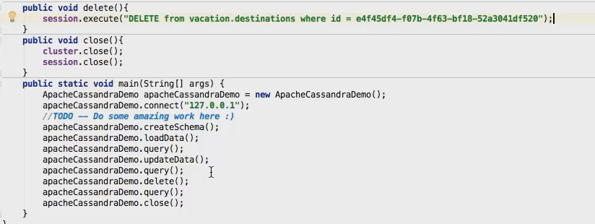

# CASSANDRA ADMIN TOOL

Datastax - Opscenter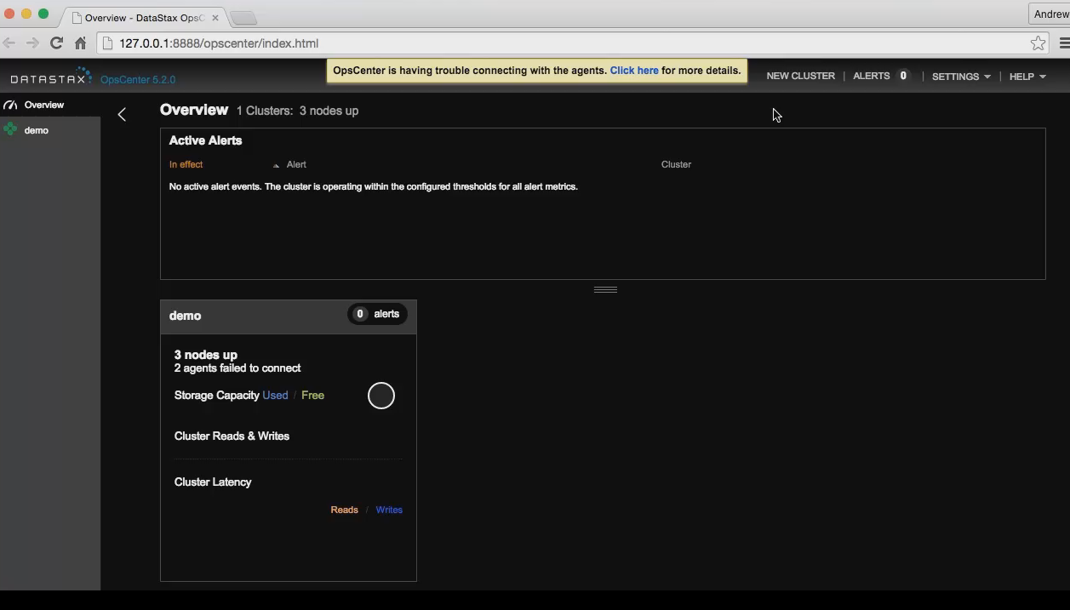

Community Tool – Heleonos is in v1.5. If you have older cluster you can use it.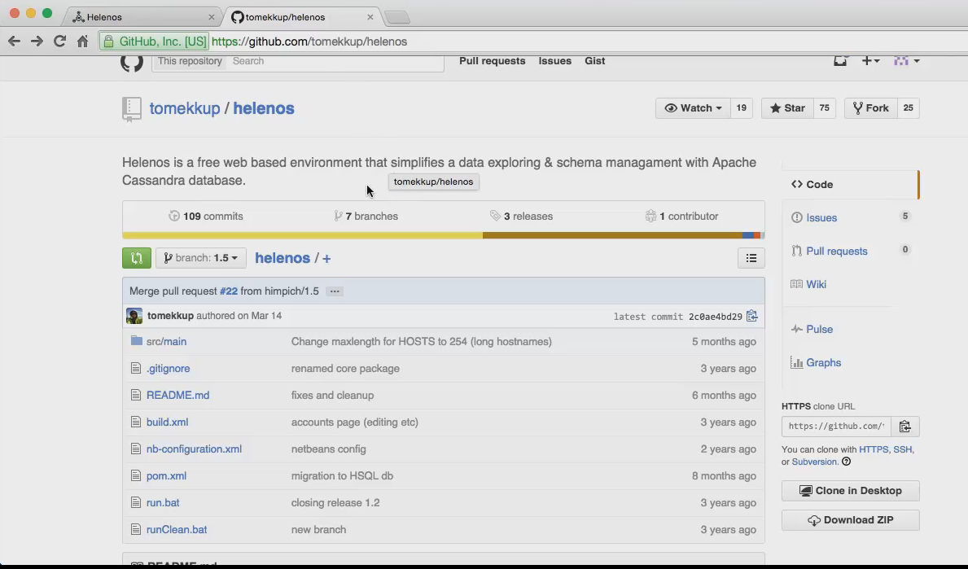

Sematext SPM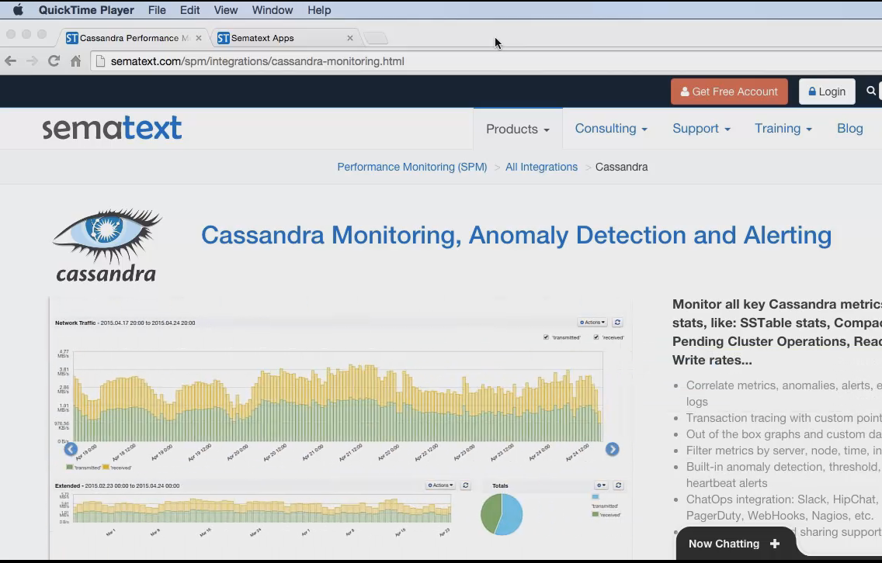

Cassandra Cluster Admin – old not useful